I'll Never Fall In Love Again
Burt Bacharach and Hal David, 1968.
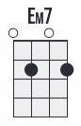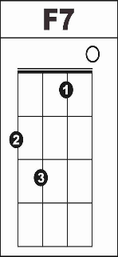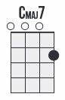

Calypso/Tropical strum
INTRO: [F] [G7] [C] [Cmaj7] [C] [Cmaj7]

Verse 1
[C] What do you get when you [Am] fall in love?
A [F] guy with a pin to burst your bubble
[Em7] That’s what you get for [Am] all your trouble

[F] I’ll . . . [Dm] never fall in love a- [F7] gai–ai–ai–[C]ain
[F] I’ll . [G7] never fall in love again [C] [Cmaj7] [C] [Cmaj7]

Verse 2
[C] What do you get when you [Am] kiss a girl?
You [F] get enough germs to catch pneumonia
[Em7] After you do . she’ll [Am] never phone ya

[F] I’ll . . . [Dm] never fall in love a- [F7] gai–ai–ai–[C]ain
[F] I’ll . [G7] never fall in love again [C] [Cmaj7] [C] [Cmaj7]

Bridge
[C/] . Don’t tell me what it’s [Dm] all a [C] bout
‘Cause [Dm] I’ve been there and I’m [C] glad I’m out
[Em7] Out of those chains, those chains that bind you
[D7] That’s why . I’m [G7] here to remind you

Verse 3
[C] What do you get when you [Am] give your heart?
You [F] get it all broken up and battered
[Em7] That's what you get, . a [A7] heart that's shattered

[F]I'll . . . [Dm]never fall in love a–[F7] gai–ai–ai–[C]ain
[F] I’ll . [G7] never fall in love again [C] [Cmaj7] [C] [Cmaj7]

Bridge
[C/] . Don't tell me what it's [Dm] all a–[C]bout
'Cause [Dm] I've been there and I'm [C] glad I'm out
[Em7] Out of those chains, those chains that bind you
[D7] That is why I'm [G7] here to remind you

Verse 4
[C] What do you get when you [Am] fall in love?
You [F] only get lies and pain and sorrow
[Em7] So for at least . un–[A7] til tomorrow,

[F] I'll . . . [Dm] never fall in love a–[F7] gai–ai–ai–[C] ain
[F] I'll . . . [Dm] never fall in love a–[F7] gai–ai–ai–[C] ain, NO

(slowly)
(fan) [F/] I'll (fan) [G7/] never fall in love a– (strum) [C] gain [Cmaj7]
[C] [Cmaj7] [C] [Cmaj7] (slow fan) [C]

